**Django-ERP User Manual**

**Personal Self-help**

## One-ticket service

### 1.1 Business Introduction

When you have the following requirements, you need to submit [Work Order Service]

[Purchase Requisition]: If you need to purchase a batch of materials or services provided by an external supplier, please fill out a work order and enter or import the details;

【Equipment Maintenance】: When you find that the company's equipment, materials, tools, buildings and other materials are damaged and cannot be used, or suspect that they are about to be damaged and affect normal use, such as office air conditioning damage, lighting fixtures not working, urinals in the bathroom blocked, lime falling off the wall, and any other matters that affect your normal use or may endanger the safety of employees, you can fill out a work order to remind the responsible person to handle it;

[Question Consultation]: If you have any questions about the company or the process, please fill in the work order and submit it. The system will assign personnel to answer your questions based on the [Business Domain] you selected. For example, if you lose your ID card and don't know how to reissue it, or you are not clear about the procedures for withdrawing provident funds, etc., you can enter them here;

[Internal Service]: When you need to handle internal service businesses such as [Business Trip], [Car Use], [Seal Use], etc., please select [Internal Service] and select the specific service you need in [Service Name], as shown below:

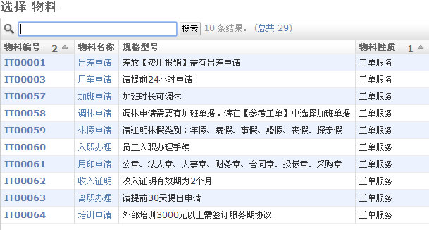

If this service has extended parameter names, please enter them in the [Extended Information] column as shown below

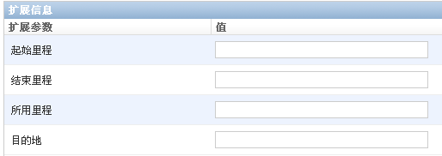

### 1.2 Interface Description

The [Add] page of the work order service is as follows:

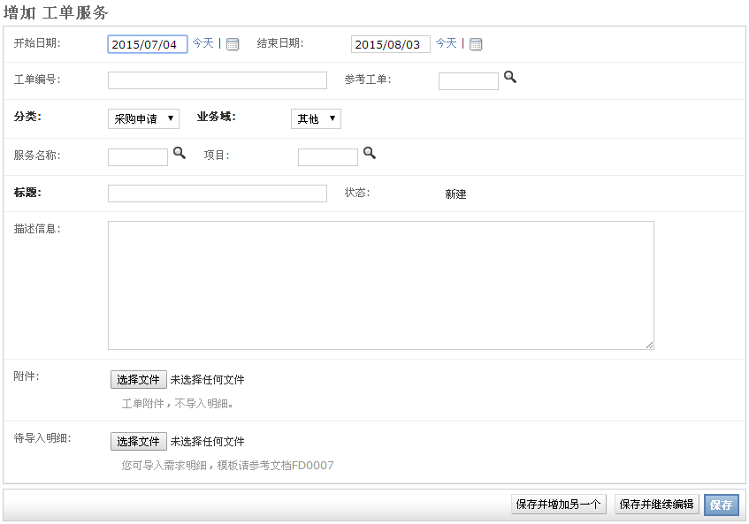

The fields are described as follows:

[Start Time]: The default is the current date, there is no mandatory business requirement, for reference only;

[End Time]: The default value is the current date plus 30 days. There is no mandatory business requirement. It is for reference only.

[Work Order Number]: Automatically generated serial number, used for retrieval;

Reference Work Order: If this work order has a reference work order, select it. For example, the Leave Adjustment Application needs to be associated with the corresponding Overtime Application.

[Classification] : Very important, with strong business relevance, it determines the page display content and process direction. For detailed introduction, please refer to Chapter 1.1;

[Business Domain]: important, with strong business relevance. If [Category] is [Question Consultation], the person in charge will be assigned based on [Business Domain];

[Service Name] : Very important, with strong business relevance. If [Category] is [Internal Service], this item is required;

[Project]: You can select the project to which the work order belongs, such as the demand plan for a specific project;

[Title]: Enter a brief description of the work order, such as: [The lighting in the F02 conference room on the 2nd floor of Building 4 is broken]

【Status】: The system automatically updates according to the approval status of the process;

【Description Information】: If the title information is not detailed enough, you can give a detailed description here;

【Attachment】: If you have more detailed requirements, you can upload attachments, such as design requirements for outsourcing design contracts;

[Import Details]: This item is used to import purchase details in batches. If you want to purchase a batch of materials, it is cumbersome to enter the demand plan item by item. You can first enter it according to the Excel template and then import it into the system again;

### 1.3 Operation Instructions

* **Step 1: Enter master document data**

After entering relevant information on the form page, click the [Save and Continue Editing] button to save the data;

* **Step 2: Enter detailed document data:**

The system determines whether to display detailed documents based on the status of the master document. For example, detailed documents are not displayed for work orders of the Problem Consultation type. After completing the detailed document, click the Continue Editing After Save button, as shown below:

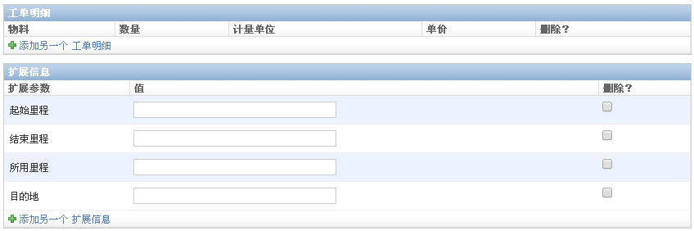

* **Step 3: Submit for approval**

After completing data entry, click the [Submit] button to enter the process approval; you can click the [History] button to view the modification history and approval history of the document;

## 2. Expense Reimbursement

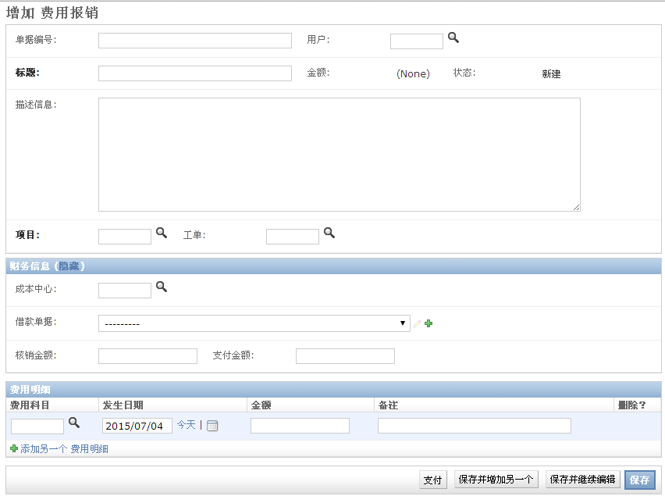

### 2.1 Business Description

Expense reimbursement is the reimbursement of miscellaneous expenses incurred by employees in the company's production activities, such as travel expenses, business entertainment expenses, gift expenses, employee welfare expenses, etc.; Django-ERP supports the aggregation of expenses to projects or work orders.

### 2.2 Interface Description

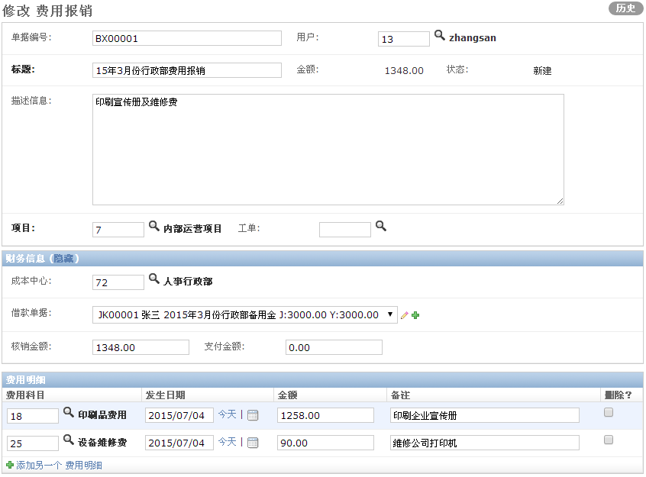

[Document Number]: Automatically generated serial number for retrieval;

【User】: The user who applies for expense reimbursement. The default user is the current user.

【Title】: A brief description of this reimbursement;

[Amount]: Automatically calculated based on [Expense Details];

【Status】: Automatically updated according to the approval status of the process;

【Description Information】: Detailed description of reimbursement;

【Project】: Project to bear the cost

Work Order: Work Order Service that is the basis for the expense, for example, the Business Trip Application work order that can select the object for travel expense reimbursement;

【Cost Center】: Filled in by the finance department, and the default value is the organization to which the applicant belongs;

【Loan Receipt】: Filled in by the finance department. If the applicant has a loan, the loan amount and loan balance will be displayed;



Among them, [JK00001] is the loan document number, [Zhang San] is the borrower, [Administrative Department Reserve Fund in March 2015] is the loan title, [J:3000] is the loan amount, and [Y:3000] is the loan balance

【Write-off Amount】: If the loan balance is greater than the reimbursement amount, the write-off amount will default to the reimbursement amount; otherwise, it will default to the loan balance.

【Payment amount】: Payment amount = Reimbursement amount - Write-off amount

[Expense Details] - [Expense Category]: Select the category to which the detailed expenses belong, such as gift expenses, transportation expenses or entertainment expenses, etc. The system has 36 built-in expense categories;

[Expense Details] - [Occurrence Date]: Enter the date on which the expense occurred;

[Expense Details]-[Amount]: Enter the amount of the expense;

[Expense Details] - [Remarks]: Please make remarks based on the actual expenses to facilitate the understanding of the financial staff;

[Pay] button: Click this button to update the document status to [Paid], process the loan document, and write off the loan amount;

### 2.3 Operation Instructions

* **staff:**
* **Step 1: Fill out the form**

Fill in the corresponding content on the new page or modification page and enter the cost details;

* **Step 2: Submit documents**

At the bottom right of the page, click the [Submit] button to enter the process approval

* **Financial staff:**

1) If it is just a process approval step, click the [Submit] button above the form;

2) If it is a payment stage, you need to click the [Pay] button first to complete the loan document verification, and then click the [Submit] button to process the process;

Note: The loan document can only be written off by clicking the [Pay] button

## Three loan applications

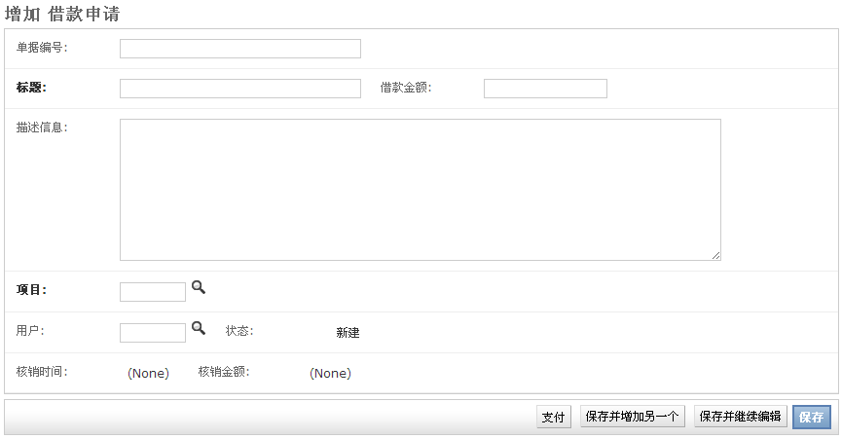

### 3.1 Business Description

Loan applications are used to apply for reserve funds for employees on business trips or daily production activities, and can be offset against loans when expenses are reimbursed.

### 3.2 Interface Description

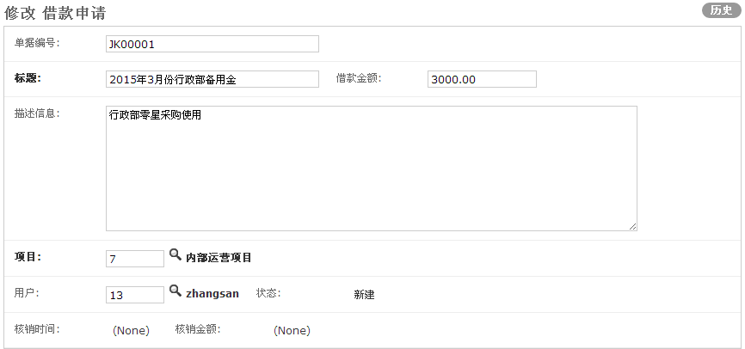

[Document Number]: Automatically generated serial number

【Title】: Briefly describe the purpose of the loan application;

【Loan amount】: Enter the amount of this loan;

【Description】: Enter the description of the loan;

【Project】: Please select the project to which the expense belongs;

【User】: Borrower, the default is the current user;

【Status】: Automatically updated according to the approval process;

[Reimbursement Time]: When the finance staff clicks the [Pay] button in [Expense Reimbursement], if this document is selected, the time here will be automatically updated as the operation time;

Write-off Amount: When the finance staff clicks the Pay button in Expense Reimbursement, if this document is selected, the write-off amount of Expense Reimbursement will be automatically accumulated here;

### 3.3 Operation Instructions

* **staff:**
* **Step 1: Enter the document information**

After the user selects the item, enters the title, and enters the amount, click the [Save and Continue Editing] button to save the data;

* **Step 2: Submit documents**

The user clicks the [Submit] button to submit for approval;

* **Financial staff:**

1) If it is just a process approval step, click the [Submit] button above the form;

2) If it is a payment stage, you need to click the [Pay] button first to complete the payment of the loan document, and then click the [Submit] button to process the process;